Forum Report: Social Planning Council of Ottawa’s Ethnocultural Seniors Forum

Aging in Your Community: Working Together to Address the Needs of Ethnocultural Seniors in Ottawa
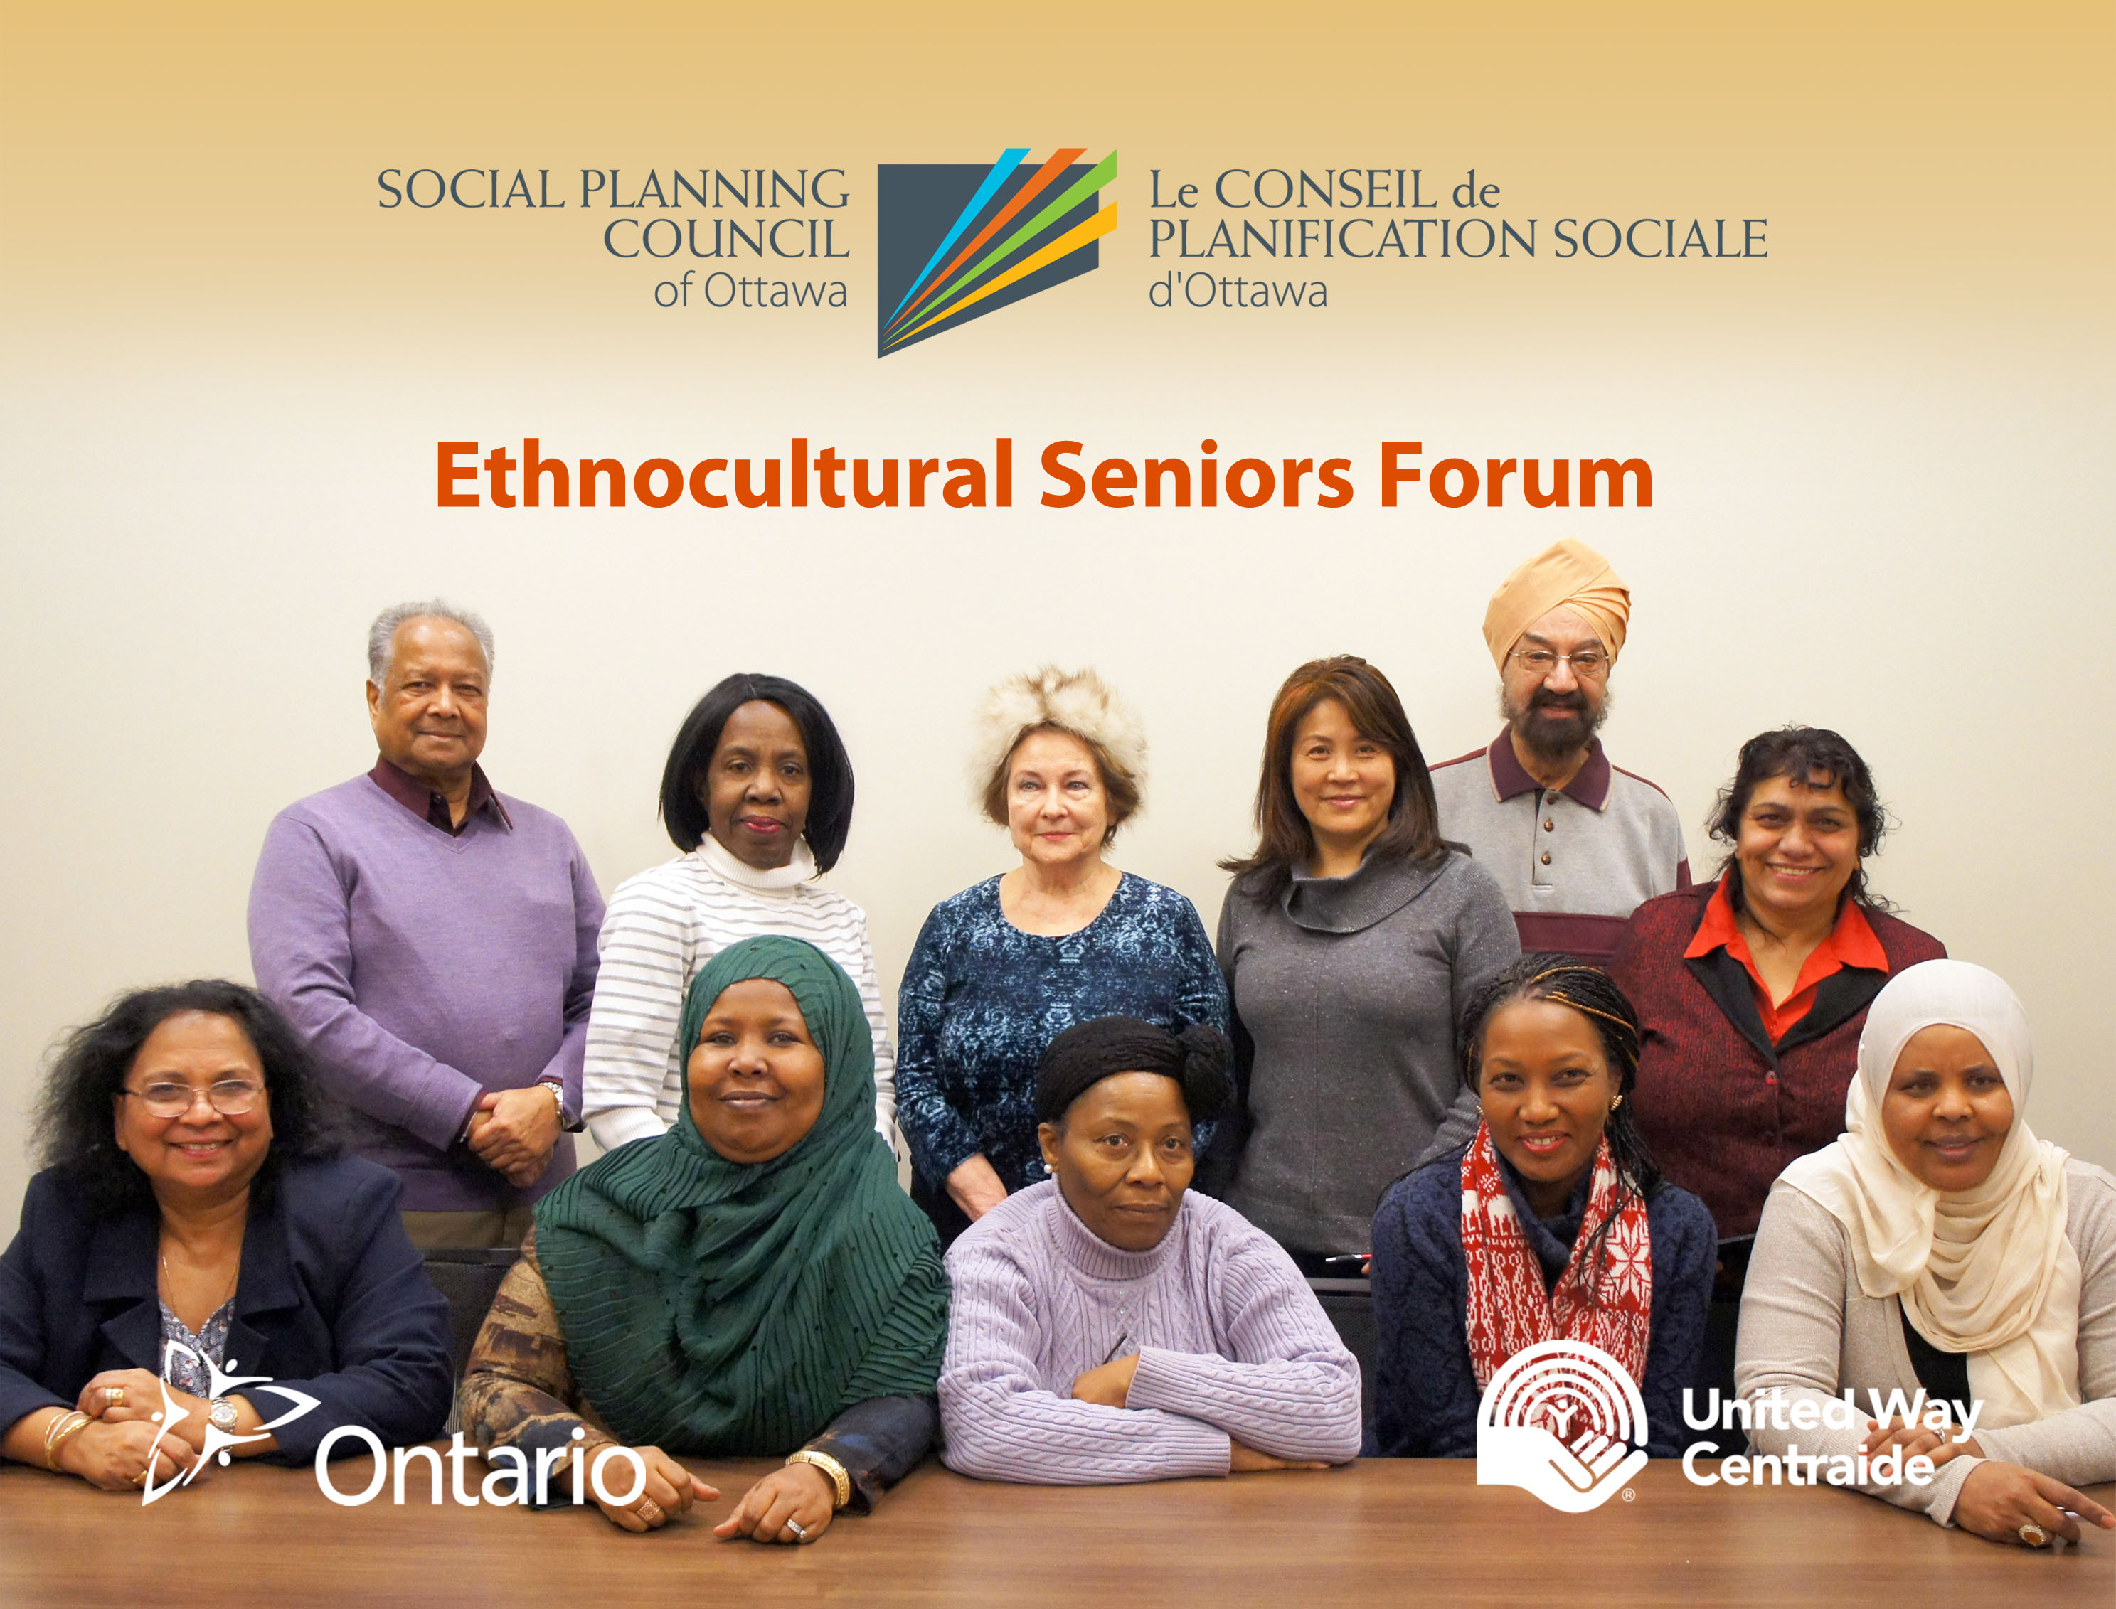

RA Centre, Ottawa, Ontario

March 14, 2018
Report prepared by: Lauren Brooks-Cleator

Report prepared by: Lauren Brooks-Cleator
Table of Contents
Introduction to the Forum Report..........................................................................................3
Acknowledgements...............................................................................................................4
Forum Program.....................................................................................................................5
Forum Summary....................................................................................................................6
Definitions of Topics..............................................................................................................7
Summary of Roundtable Discussions.....................................................................................8
Transportation and Mobility.......................................................................................8
Communication and Information................................................................................9
Community and Health Services................................................................................10
Availability of Space for Activities..............................................................................11
Social Participation and Inclusion..............................................................................12
Next Steps...........................................................................................................................13
Appendix A: List of Cultural Performances...........................................................................15
Appendix B: Summary of Forum Evaluations.......................................................................16
Appendix C: Cultural Profiles...............................................................................................17

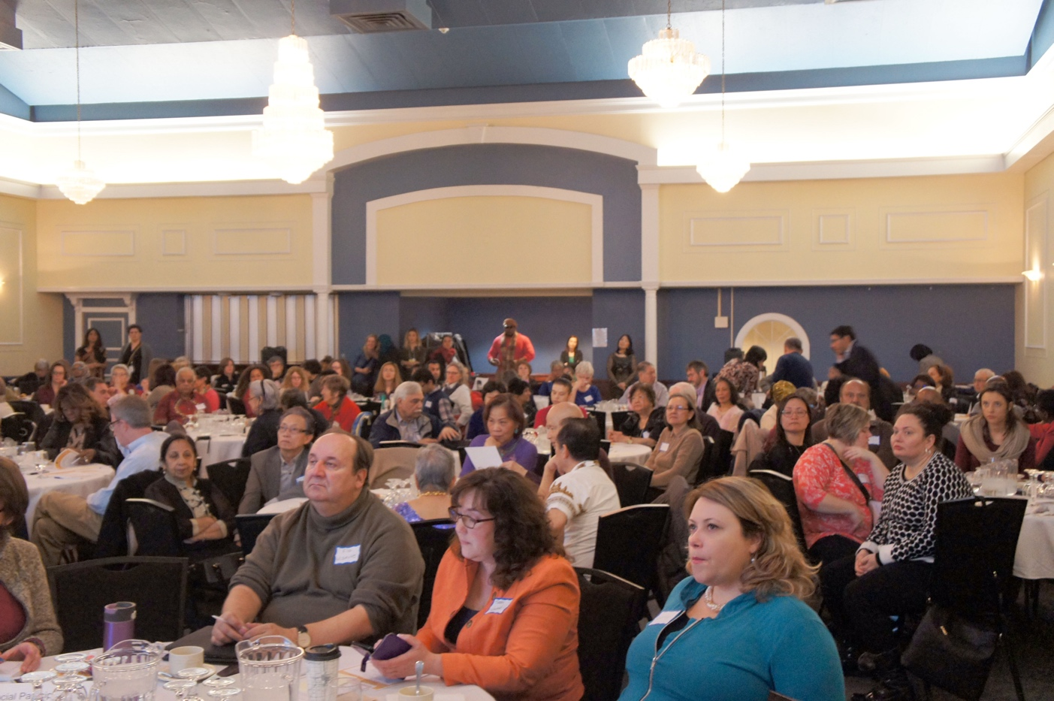

Introduction to the Forum Report

The objective of this report is to provide an overview of the purpose of the Forum, a summary of the information presented, and insights gained through roundtable discussions with Forum participants. This document demonstrates the growing interest in addressing the needs of ethnocultural minority seniors in Ottawa and reflects the interests and concerns of seniors, service providers, and other community members shared through the Forum. Under each theme in the roundtable discussions, opportunities for future action and suggestions for next steps are outlined, with a minimum of one Action Strategy per topic. These Action Strategies highlight some initial good practices that could be carried forward by various community stakeholders to address some of the recommendations stemming from the Forum.

The Social Planning Council of Ottawa (SPCO), through funding from the United Way Ottawa and the Government of Canada’s New Horizons for Seniors Program, offers support to over 20 grassroots ethnocultural seniors’ groups. These groups, primarily run by very dedicated and hardworking volunteers, provide a range of social and recreational activities, workshops, and individual support to promote the inclusion of over 3000 ethnocultural minority seniors in Ottawa.

While these groups are serving a large need in the community, it is important to recognize the reciprocal relationship of service providers, volunteers, seniors, and many others in working together to address the needs of ethnocultural minority seniors.

Collectively, many of the groups identified five important topics for the Forum roundtable discussions: transportation and mobility, communication and information, community and health services, availability of spaces for activities, and social participation and inclusion. There are numerous challenges that ethnocultural seniors in Ottawa face, but despite these challenges there are many opportunities to strengthen ethnocultural minority communities’ relationships with community organizations, build upon their strengths and knowledge, and begin dialogue to support seniors to age well, the Forum being one of these opportunities. It provided a chance to begin dialogue, build partnerships, and develop solutions for moving forward to support ethnocultural minority seniors in the community of Ottawa.

It was hoped that through the Forum, the first of its kind in Ottawa, ethnocultural minority seniors would be able to share their concerns and solutions with service providers and decision-makers, who would then gain a better understanding of these issues to ensure the inclusion of ethnocultural minority seniors’ needs moving forward.

Acknowledgements

There were many people who helped to organize the Forum and make it a success, including the Forum Planning Committee, ethnocultural group leaders, senior performers from the ethnocultural groups, student volunteer facilitators from Carleton University and the University of Ottawa, and funders.

Forum Planning Committee
- Sybil Braganza, Coordinator, Creating Community for Isolated Ethno-Cultural Seniors, Social Planning Council of Ottawa
- Cinthia Pagé, Specialist, Partner and Stakeholder Initiatives, Community and Social Services, City of Ottawa
- Lise Racicot, Patient and Stakeholder Engagement Coordinator, Champlain LHIN
- Anil Sukhija, Chair, Seniors Program Committee, Indo-Canadian Community Centre
- Lauren Brooks-Cleator, Co-Evaluator, Keeping Ottawa Seniors Connected & Doctoral Student, University of Ottawa

Technical and Design Support
- Luong Le Phan, Chair, Vietnamese Canadian Community of Ottawa

Forum Funders
- Government of Ontario
- United Way Ottawa

Ethnocultural Seniors’ Groups

- Cambodian Association of Ottawa Valley
- Canada Nepal Solidarity for Peace
- Club Casa de los Abuelos
- Deshantari of Ottawa Carleton
- Excelsior Cultural and Spiritual Association
- Family Support and Care Services
- Indo-Canadian Community Centre Seniors
- Indo-Canadian Services Association Barrhaven, Ottawa
- Kanata Chinese Seniors Support Centre
- Light of Life
- Lotus Multicultural Friends – Ottawa
- National Capital Region Bulgarian Community
- Nord-Sud Développement Racines et Cultures
- Ottawa Korean Evergreen Society
- Ottawa Valley Filipino Canadian Seniors Citizen Association
- Polish Canadian Women's Federation
- Regroupement Affaires Femmes
- Rwanda Social Services and Family Counselling
- Sikh Community Services Ottawa
- South Nepean Muslim Centre
- Sri Lanka Canada Association of Ottawa
- Vietnamese Canadian Community of Ottawa

Forum Program

Aging in Your Community: Working Together to Address the Needs of Ethnocultural Seniors in Ottawa
RA Centre, 2451 Riverside Drive, Clark Hall Room
Wednesday, March 14, 2018
8:30am – 1:30pm

8:30 am–9:00 am Registration/Breakfast/Display Tables/Networking

9:00 am–9:10 am Welcoming Remarks:
Mr. Anil Sukhija, Chair, Seniors Program Committee
Indo-Canadian Community Center
Ms. Lauren Brooks-Cleator, Keeping Ottawa Seniors Connected

9:10 am–9:15 am Video Presentation Greetings
Honourable Dipika Damerla, Minister of Seniors Affairs, Government of Ontario

9:15 am–9:20 am Greetings
Mr. John Fraser, MPP Ottawa South

9:20 am–9:25 am Greetings
Honourable Mayor Jim Watson, City of Ottawa

9:30 am–10:00 am Keynote Speaker
Dr. Susan Braedley, Associate Professor, School of Social Work, Carleton University
“Learning From/Learning with Ethnocultural Seniors: Supporting Social Change through Research”

10:00 am–10:20 am Break

10:20 am–12:00 am Roundtable Discussions

12:00 am–12:10 pm Next Steps and Closing Remarks
Dianne Urquhart, Executive Director, Social Planning Council of Ottawa

12: 10 pm–1:30 pm Cultural Celebration/Display Tables/Networking

Forum Summary

The Forum was attended by over 200 seniors, service providers, decision-makers, and other community members. Specifically, forum attendees included local politicians John Fraser, MPP Ottawa South, and Honourable Jim Watson, Mayor for City of Ottawa; Dr. Susan Braedley, Associate Professor from Carleton University; the leaders and some members from over 20 grassroots ethnocultural seniors groups; service providers from a variety of organizations, including community health centres, community support services, seniors’ centres, City of Ottawa, the Champlain LHIN, and many others; and interested community members representing volunteers and advocates for seniors.

The objectives of the Forum were:
- To increase the knowledge and understanding of the needs of Ottawa's ethnocultural seniors and how we can work together to address them;
- To enrich the understanding of service providers of the unique needs of ethnocultural minority seniors;
- To educate mainstream population about what ethnocultural minority seniors have contributed in our society; and
- To increase cross-cultural understanding.

Dr. Susan Braedley, the keynote speaker set the tone for the Forum, reminding those assembled that while ethnocultural seniors have many common issues, including struggles with social isolation, it is important to recognize their differences. She noted that gender is an important consideration, as is length of time in Canada, language, income, and histories of trauma, including war and genocide. She noted that ethnocultural seniors' contributions to Canadian society are worthy of more attention. Yet, some ethnocultural seniors have restricted opportunities to make other contributions, and these restrictions need to be addressed. She encouraged the Forum participants to consider the conditions in which ethnocultural seniors can live and contribute with dignity and respect.

The key messages of the Forum were:
- Seniors, service providers, decision-makers, and community members need to work together to address the needs of ethnocultural minority seniors.
- There is a lack of recognition of the unique challenges that ethnocultural minority seniors face, despite sharing similar challenges to seniors from the mainstream population.
- Ethnocultural minority seniors make significant social and economic contributions to the community.
- Ethnocultural minority seniors have lived experience and knowledge of how to address their needs to support them in aging well.

To close the Forum, seniors from the ethnocultural minority groups engaged the attendees with cultural performances (see Appendix A for a list of the cultural performances).

Definitions of Topics

Representatives from ethnocultural minority seniors’ groups collectively identified five important topics for the Forum roundtable discussions: transportation and mobility, communication and information, community and health services, availability of spaces for activities, and social participation and inclusion. Each topic is defined below.

Transportation and Mobility
Transportation, including driving, taking the bus, walking and cycling, is important to ethnocultural seniors. It helps them be independent and active. It helps them take part in social, cultural and recreational activities. It helps them get to work, shop or go to appointments. Age friendly transportation options are safe and easy to use.

Communication and Information
Communication helps seniors get practical information about events, services and resources. Access to information is essential for active and healthy aging. Ethnocultural seniors should be getting the right information, at the right time and in the right format.

Community and Health Services
Community support services help seniors to live independently and safely in their own homes. They can help with routine household activities, home maintenance, personal or respite care. Health services protect and improve health and wellness. They encourage physical activity and promote preventive health programs.

Availability of Spaces for Activities
Having access to spaces (rooms, halls, buildings) for organized activities is a common concern amongst groups of ethnocultural seniors. Easy and affordable access to meeting spaces can have positive impacts on the level of social activities and quality of life of seniors.

Social Participation and Inclusion
Seniors want to play an active role in their community. Being respected and included help seniors have healthy lives. Social participation help prevent diseases and reduce isolation. Research shows that those who remain actively engaged in life and socially connected are happier and live longer.

Summary of Roundtable Discussions

The objectives of the facilitated roundtable discussions were to:
- Identify successes and issues regarding the 5 topics and
- Collect suggestions for actions needed to address the identified gaps and issues.

There were 15 tables with 3 tables assigned for each topic. Participants at each table represented seniors, service providers, decision-makers, and community members. Based on their assigned topic, participants were asked to answer the following questions:
- What is working well?
- What is not working well?
- How can we improve the situation?
- What are the actions I can commit to doing to improve the situation?

Participants at each table provided many responses to each question. Below is a summary for each topic.

Transportation and Mobility

Working Well
Participants discussed how services that provide transportation for seniors, such as seniors’ centres, ParaTranspo, places of worship, and the LHIN, are working well, and the benefits of OC Transpo’s seniors’ day on Wednesdays. Participants also discussed how technology can make it easier to schedule rides and navigate the public transportation system in Ottawa. Bus travel support is another piece that is working well, which includes community members who offer interpretation for seniors for the OC Transpo and OC Transpo navigation training offered by community members for newcomers. Another topic that participants discussed that is working well are the safety initiatives for pedestrians, such as the Council on Aging’s Committee, consultations with seniors, new crossings, slip-resistant material used for sidewalks, increased accessibility buttons, and improved cycling infrastructure.

Not Working Well
Some of the areas that are working well also present barriers, creating aspects that do not work well. Related to the OC Transpo, participants discussed how having the seniors’ day on only one day of the week is too limited; navigating the bus system can be difficult, especially when the bus drivers do not call the stops; seniors do not have smartphones, and they have to take more complicated bus routes; despite having lower fares for seniors, participants discussed how bus fare is still somewhat unaffordable; and that there are many difficulties with using ParaTranspo, such as it not arriving on time, having a long wait list, being too limited eligibility, and having a difficult scheduling system. Additionally, participants discussed how seniors living in rural areas can have a particularly difficult time with transportation, especially if they do not drive. Participants also noted that though there are positive aspects of pedestrian safety, there are still things that are not working well, such as timely snow clearing, driver education, and inaccessible crosswalk curbs.

Actions/Solutions
Participants provided numerous suggestions for actions and solutions related to transportation. These included:
- Ethnocultural minority community working with existing transportation advocates (e.g., Council on Aging Committee);
- Having volunteers who speak the language, and providing more support/incentives for them to volunteer;
- Providing training to seniors on navigating the bus system, transportation services available and how to access them, working with youth who can speak the language who can help with training, and training bus drivers on how to help seniors with language barriers;
- OC Transpo’s seniors’ day being more flexible and free for seniors’ companions;
- Encouraging seniors to vote, to contact the City of Ottawa with their concerns related to transportation, and to participate in City consultations;
- Improving street lighting (e.g., Riverside and Carling) and ensuring there are working solar lights;
- Learning about best practices from other cities; and
- Obtaining more funding for services (e.g., health, seniors’ centres, etc.) to provide transportation.

Key Action Strategies
- Build upon the promising practice of the ethnocultural seniors groups who provide OC Transpo training to their members (e.g., Club Casa de los Abuelos, Canada Nepal Solidarity for Peace) and continue providing bus tickets for this purpose.
Key Actor(s): City of Ottawa, ethnocultural seniors groups
- Advocate for more flexible free senior rides on OC Transpo.
Key Actor(s): Council on Aging of Ottawa’s Transportation Committee, City of Ottawa

Communication and Information

Working Well
The roundtable discussions revealed that the opportunities to learn English are working well. These include formal ESL classes, conversation circles, and informal opportunities through participating in various multicultural activities. Participants also discussed the benefits of settlement support for newcomers, which provide important information about living in Ottawa and Canada. Another aspect of communication that is working well is spreading information through word of mouth; community leaders share information and seniors have many opportunities to share information with each other at events and gatherings. The intergenerational opportunities are also working well because youth are able to teach seniors about technology and ways to access information, and the youth can also learn from the seniors. The availability of translation and interpretation services through some organizations is also working well, such as through the hard work of volunteers, and at the Immigrant Women’s Service of Ottawa.

Not Working Well
Navigation of information was a very common theme that participants found was not working well. Challenges related to navigation include lack of advertising in a variety of formats, scattered information that is not easy to find, difficulties using or accessing technology, lack of timely information, and being transferred from person to person or service to service (e.g., through 211). Also, while interpretation and translation services are available, many participants felt that there is not enough and can sometimes be improperly done, which is particularly challenging for seniors without family close by. Areas where participants felt that these services are not working well include health services, 911 services, and print and web-based information. Another aspect of communication that participants felt was not working well was that service providers do not always understand or respect cultural differences that exist between them and their clients, and that there is a lack of cultural diversity among staff, which contributes to some of these challenges.

Actions/Solutions
Actions and solutions related to communication and information included:
- Having seniors-specific communication, such as tailored printed information and websites and more seniors’ issues in mainstream media (e.g., radio, local television stations);
- Using technology, such as translation software;
- Forming partnerships with and between researchers, seniors, and service providers to find ways to address the barriers;
- Lobbying for more funding for interpretation and translation;
- Delivering cultural competency training for service providers;
- Providing more support to volunteers who provide interpretation and translation, including supporting youth to help seniors;
- Expanding opportunities in the city to learn English both formally and informally;
- Connecting service providers with ethnocultural minority community leaders, such as those they met at the forum, as a means of sharing information with the seniors; and
- Utilizing diverse communication strategies, such as pictograms and having more languages available.
Key Action Strategy
- Similar to those offered in Toronto, develop an online resource that lists free interpretation services for ethnocultural seniors.
Key Actor(s): Community health centres, community resource centres, cultural-specific organizations, SPCO advocacy group

Community and Health Services

Working Well
The main part of community and health services that participants felt is working well is that there are numerous resources that are shared with seniors. This mainly includes health information through documents, workshops, seminars, etc.

Not Working Well
While there are many resources that ethnocultural minority seniors have access to, participants felt that the information from the documents and from service providers can sometimes be difficult to understand, especially for seniors whose first language is not English or French. There is a lack of information pertaining to what health and community services are available and how to access them. Participants also felt that care support is a challenge because there is a lack of follow up after a hospital discharges a senior. Seniors feel they have to rely too heavily on family and friends for support, and there is a lack of support for caregivers. Similar to the concerns expressed at the Communication and Information tables, participants felt that some health and community service providers lack cultural competency and that it is quite challenging for ethnocultural minority seniors when these services do not have available translation and interpretation services.

Actions/Solutions
Participants provided numerous suggestions for actions and solutions related to transportation. These included:
- Having a greater range of languages available and more translation and interpretation services;
- Connecting with ethnocultural minority community leaders to find volunteers, and to share information about available resources and services;
- Increasing support for improved coordination and navigation of health and community services;
- Providing transportation for health appointments through volunteers or seniors’ centres;
- Using technology to help with translation and interpretation for both seniors and service providers;
- Increasing collaboration between health and community services and ethnocultural minority communities to determine their specific needs and how to address them;
- Providing cultural competency training for health and community service providers;
- Training for health and community service providers on supports available that are specific to certain ethnocultural minority communities; and
- Increasing opportunities for more culturally diverse health and community service providers.

Key Action Strategies

1. Through partnerships with and between researchers, seniors, and service providers research and put into action ways to address the barriers.
Key Actor(s): Learning institutions (i.e. University of Ottawa, Carleton University), Community health centres, community resource centres, cultural-specific organizations, SPCO advocacy group

2. Through education at the community level, increase knowledge of available resources and how to access these resources.
Key Actor(s): government agencies i.e Local Health Integration Network (LHIN) Ontario Disability Support Program (ODSP), City of Ottawa Public Health, local hospitals, community health centres, community resource centres, cultural-specific organizations, SPCO advocacy groups

3. Through partnerships with and between learning institution and community organizations providing services in the community to promote and provide culturally responsive service delivery for front line staff.
Key Actor(s): government agencies i.e Local Health Integration Network (LHIN), City of Ottawa Public Health, local hospitals, community health centres, community resource centres, cultural-specific organizations, SPCO advocacy groups

4. Similar to those offered in Toronto, develop an online resource that lists free interpretation services for ethnocultural seniors including raise awareness on where these services are available and how to access them (i.e. TOH interpretation services)
Key Actor(s): Community health centres, community resource centres, cultural-specific organizations, SPCO advocacy group

5. Through partnerships with and between researchers, learning institute and service providers, increase opportunities for more culturally diverse health and community service providers
Key Actor(s): University and college related health and social services programs, SPCO advocacy group

Availability of Space for Activities

Working Well
Participants felt that it is working well, that there are many public spaces for activities (e.g., malls, museums, and libraries), and that community organizations deliver programs and have available space (e.g., community resource centres, community centres, and seniors’ centres). Participants also noted that it is beneficial to have discounted rates for seniors’ groups at some locations.

Not Working Well
While there are spaces available for activities, many of the participants discussed that they are not working well because the rental fees are too high for many of the grassroots volunteer-led groups. Other challenges are related to the physical environment, such as lack of accessibility and parking; availability, such as on specific days and during peak hours; navigation of finding available space and using the complex booking systems; and the complicated logistics, such as insurance requirements and lack of storage space.

Actions/Solutions
Actions and solutions suggested by the participants included:
- Having more flexible space within current locations (e.g., community centres, seniors’ centres) by having shared space, computer space, retreat space, and cooking space;
- Improving outreach and communication about availability;
- Developing a map of available public and private spaces within city;
- Simplifying booking systems;
- Addressing the issue of accessibility;
- Lobbying for more affordable space by contacting politicians, voting, and getting involved with the City’s Seniors’ Roundtable; and
- Having lower, more affordable rental fees for grassroots, volunteer-run seniors’ groups
Key Action Strategy
- Seek out simplified processes for developing Memoranda of Understanding with ethnocultural seniors’ groups to provide them with access to no or low-cost space that is not used on a regular basis.
Key Actor(s): Community health centres, community resource centres, seniors’ centres, private businesses

Social Participation and Inclusion

Working Well
Participants discussed how there are many benefits to having ethnocultural-specific groups to participate in, including their support with transportation, outreach, socializing, and workshops, and that these groups would not be available without the financial support from the SPCO and from the federal, provincial, and municipal governments. Additionally, the opportunities to volunteer in the community and the use of social media to share information about activities are working well. It was also mentioned that the participation of politicians in cultural celebrations and in hosting community events helps them feel included.

Not Working Well
Participants identified several themes that contribute to lack of social participation and inclusion for ethnocultural minority seniors, including lack of awareness of community activities, language barriers, isolation (even if seniors do not live alone), lack of transportation, lack of respect for cultural differences, and lack of continuous funding for grassroots volunteer-led seniors’ groups. Another challenge is that these groups are very dependent on volunteers with little recognition of their efforts, which is not always sustainable as the volunteers can easily become overworked resulting in less opportunities for social participation for some seniors.

Actions/Solutions
Actions and solutions suggested by the participants included:
- Fostering more connection between all seniors in Ottawa by breaking stereotypes and encouraging inclusion of ethnocultural minority seniors;
- Having more culturally-specific programs;
- Improving communication about activities and event;
- Increasing focus on intergenerational activities to preserve language and history to foster intergenerational relationships;
- Improving navigation of federal government immigration resources for seniors;
- Helping seniors to understand role of volunteers and how they can volunteer in the community;
- Having greater recognition of volunteers; and
- Improving funding support by having ongoing or longer-term of funding and simplified applications.
Key Action Strategies
- Build upon the Council on Aging of Ottawa’s Service to Seniors Awards that recognize the volunteer contributions that ethnocultural seniors make to their communities, and Ottawa as a whole.
Key Actor(s): City of Ottawa, Council on Aging of Ottawa
- Actively engage ethnocultural senior leaders in meaningful advisory positions on committees and groups that advocate for the needs of all seniors in Ottawa.
Key Actor(s): City of Ottawa, Council on Aging of Ottawa, United Way Ottawa

Next Steps

The Forum was the first step in fostering productive and meaningful relationships between service providers, decision-makers, ethnocultural minority seniors, and community members. In her closing remarks, the SPCO executive director, Dianne Urquhart suggested that all participants have a responsibility to ensure that these relationships continue so that these conversations can lead to a more meaningful and positive changes in the community. This report provides many suggestions and actions to address the needs of ethnocultural minority seniors and can be a tool for community and health services organizations, policy-makers, the City of Ottawa, researchers, and others to use to advance the issues highlighted in the report. The key Action Strategies identified in this report demonstrate the meaningful suggestions that can be acted upon to more fully address the needs of ethnocultural minority seniors in Ottawa. As the recommendations and Action Strategies demonstrate, it is not just the responsibility of one organization, committee, or group to act on these items; it requires a cross-sectoral strategy to better support grassroots groups to clear the barriers that impede their ability to provide support to ethnocultural minority seniors. This report calls attention to ethnocultural minority seniors to show how enabling grassroots, peer-to-peer, and neighbour-to-neighbour supports is key to supporting healthy aging in Ottawa. As a result of the Forum, an advocacy group will be created by the SPCO. This committee will engage with a collection of community stakeholders to coordinate efforts towards addressing and measuring progress on the recommendations and Action Strategies. The SPCO continues to provide support to grassroots ethnocultural seniors’ groups, but it is the community’s responsibility to support seniors in aging well.

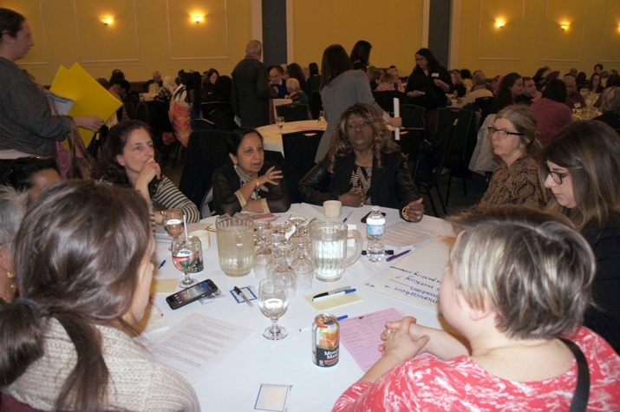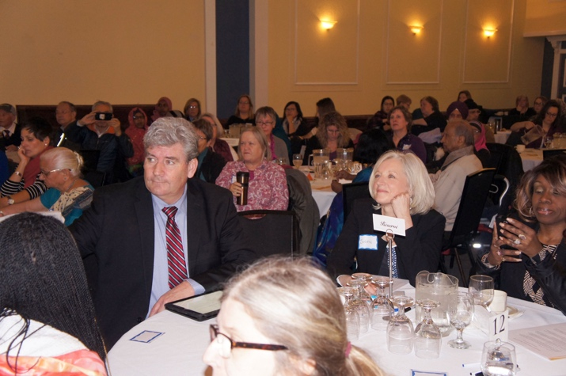

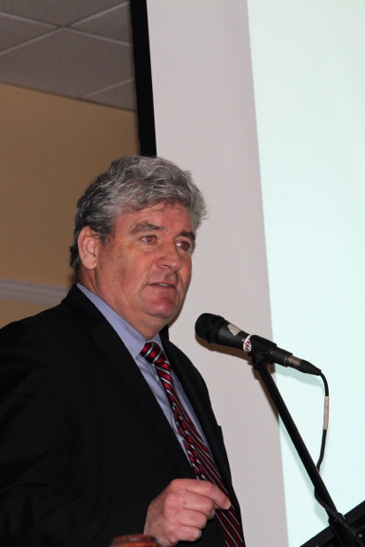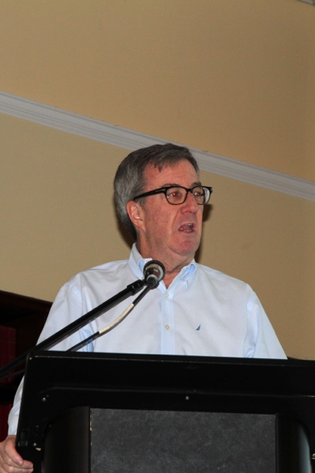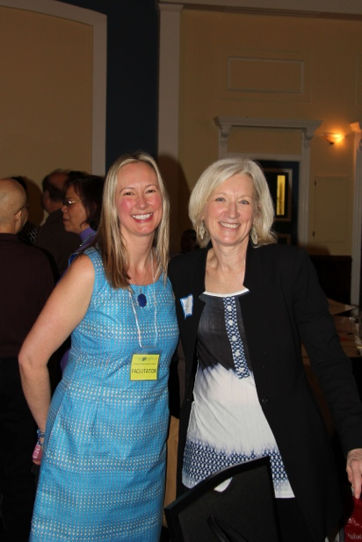

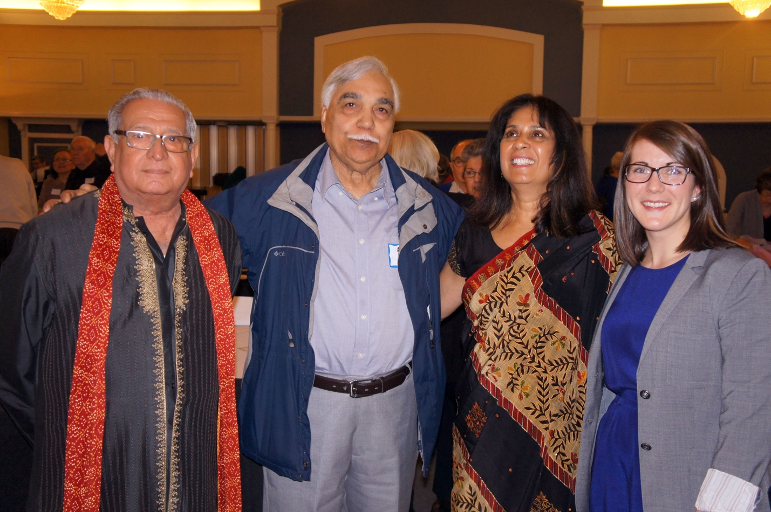

Appendix A: List of Cultural Performances

- Ottawa Valley Filipino Canadian Seniors Citizen Association
CARINOSA - Carinosa is a Spanish word that comes from the word carino meaning caress or affection. The men in this dance try to attract the ladies by using a kerchief. The ladies, who are very shy, try to avoid them and use a fan to cover their face. The ladies' costume is a beaded top and long skirt, while the men wear a white shirt called barong, which is made of pineapple fibre.
Dancers: Telly Joaquin and Pat Martin Lamanne, Lydia Blondin and Benita Araneta Belinda, and Yabut and Ester Placido.

- AECS /ECSA Excelsior Cultural and Spiritual Association
Je vole, comme un oiseau, je vole - I fly, like a bird, I am flying
The general meaning is as long as we have life, health and possibilities we will keep on moving and acting.
Performer: Marlene Casimir

- Sri Lankan Canada Association of Ottawa (Seniors’ Group)
Mr. Tansen A Edirisinghe - playing thabla, and Professor Nimal De Silva -playing guitar and singing Sri Lankan songs.

- Regroupement Affaires Femmes
Song: Nostalgie by Violène Gabriel

- Lotus Multicultural Friends Ottawa
The Thai Dance Troupe of Ottawa presents the "Soul Blessing Dance and Ceremony" in the traditional Thai style.

- Canada Nepal Solidarity for Peace
Old traditional song from 1800s. First part of the song is about missing the mother land. Explaining the beauty of the mountains, hillside, meandering river, and lovely forest. “I am faraway but my heart is there.” The second song is a love song.

- Somali Seniors
Saylici - Traditional Somali Dance.

- Sikh Community Services Ottawa (Seniors) and Indo Canadian Community Center
Traditional Punjabi Folk Dance.

Appendix B: Summary of Forum Evaluations

EVALUATION FORM

Overall forum evaluation. | Excellent  58 | Very good  41 |  | Good  6 |  | Fair  0 | Poor  0
The topic of this forum is important to me. | Strongly agree  65 | Agree  45 |  | Disagree  0 |  | Strongly disagree  0 | Unsure  0
I liked the format of the forum (i.e., Keynote and roundtable). | Strongly agree  54 | Agree  54 |  | Disagree  0 |  | Strongly disagree  0 | Unsure  0
The keynote presentation was interesting and relevant. | Strongly agree  58 | Agree  46 |  | Disagree  0 |  | Strongly disagree  0 | Unsure  0
The roundtable discussions were valuable and informative. | Strongly agree  62 | Agree  39 |  | Disagree  0 |  | Strongly disagree  0 | Unsure  0
Age category. | Under 35  5 | 35-44  6 |  | 45-54  21 |  | 55-64  22 | 65 and over  51
Participant category. | Service provider  24 |  | Community Member  49 |  | Other (please specify): Social work  Translator

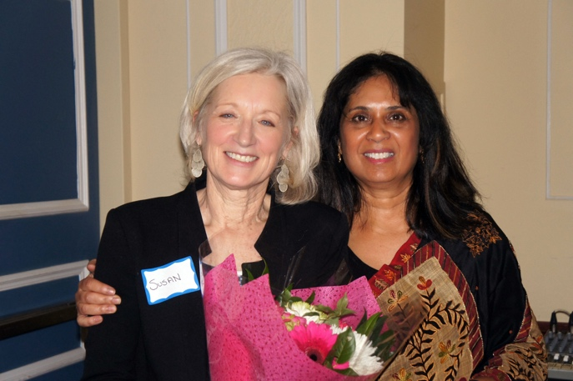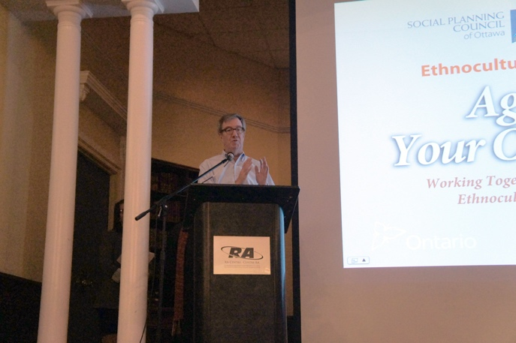

Appendix C: Cultural Profiles (provided by ethnocultural group leaders)

Cultural Profile

CANADA NEPAL SOLIDARITY FOR PEACE (CNSFP)
Background: CNSFP is a non-profit, volunteer organization created in 2006 which provides counselling and advocacy services to immigrants and refugees in Canada, supporting their integration into Canadian Society and culture. It works to build cross cultural relationships among various ethnic groups.

The CNSFP runs many events in hopes of making newly immigrants feel welcome in Canada and this organization was formed to break isolation, increase self-esteem, and self-confidence among the different ethnocultural groups.

Tara Upreti, the founder of the CNSFP, has been working for change and helping the youth and elderly for more than 15 years. She has increased awareness and involvement in the ethno-cultural seniors’ issues, making presentations and working in Coalitions such as the Ottawa Ethno-cultural Coalitions. Importantly she has provided opportunities for able seniors and young people to volunteer with this community. She was awarded by the Council of Aging Ottawa in 2016 for her work with the seniors in the community.

Programs: There are many different types of events that the CNSFP runs yearly such as cultural events to demonstrate the diversity and talent of the youth, intergenerational activities that connect youth and the elderly and support groups for the elderly and single parents.

Key programs offered: Once a week, our group for the elderly meet up for socialization, where we provide a safe place to express their feelings and where we do cultural appropriate activities such as storytelling, yoga (mindfulness), exercise, tours, individual meeting, home visit, grieving and hospital visits. This is performed so group members can feel more interconnected and feel harmony during the weekly meetings. All of these activities are performed for the seniors in the Nepali language.

Other programs offered:
- Emotional counselling
- Wellness programs- Mindfulness, yoga, exercise
- Youth and children programs, as leadership training
- Nepali language program- credit and non-credit courses
- Crisis intervention and support services
- English/Nepali interpretation
Once a year we coordinate a fundraising event for the Women’s Foundation of Nepal to raise money to help their shelter get food, water and other necessary items.

For more information please contact:
Tara Upreti
Cell-Phone: 8193180655
E-mail: t_upreti@hotmail.com
Website: www.cnsp.ca

Cultural Profile

CLUB CASA DE LOS ABUELOS (THE GRANDPARENTS’ HOUSE)

The Voice of the Spanish Elderly in the Nation’s Capital Since March 2004

Background Information: Club Casa de los Abuelos (CCA) was established in March 2004 in response to the luck of programs to enrich the quality of life of Spanish-speaking seniors who were living isolated lives due to language barriers, limited income or absence of cultural appropriate programs.
Since its inception CCA has provided social, recreational and educational activities therefore improving the life of its members by promoting active living and reducing sedentary life-styles. The organization is run solely by dedicated, compassionated and committed “Donors of Human Capital - Volunteers” of which 98% are seniors.

Languages Spoken: Spanish, Bulgarian, Russian, German, Portuguese, English and French.

Cultural Values and Customs: family (or lack of thereof); music; honesty, hard-working, mutual respect, mutual support, sharing knowledge, skills and expertise.

Holidays and Celebrations: The last Saturday of every month (except December) the organization host the collective birthday celebrations; Valentine’s, Day; Mother’s Day; Summer picnic, Annual Open House, Christmas dinner; monthly executive meeting as well as the Annual General Meeting. Depending on finances, the organizations offers one or two outings out of town a year. One is a visit to enjoy the Canadian experience of the sugar bush and the other in the summer to visit a touristic small town/village close to Ottawa.
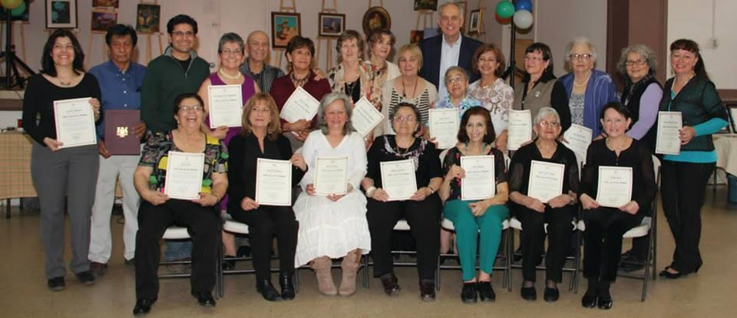
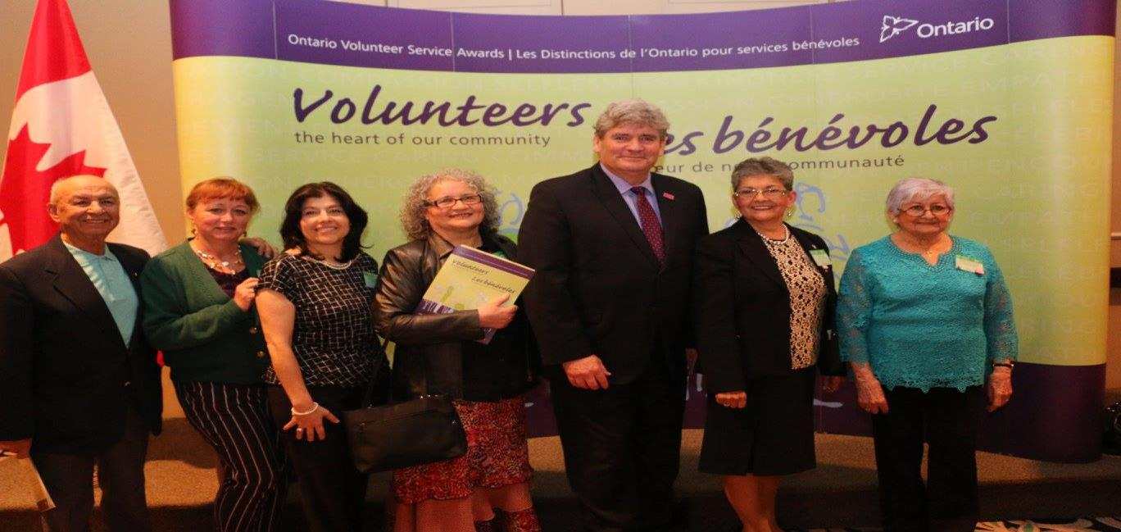

Achievements and Contributions made in their homeland and Canada by the members of the group: CCA does not track what members of the organization do for the benefit of their homeland. CCA works tireless to enhance the quality of life for all seniors in the Nation’s Capital and has become a fearless advocator on seniors’ issues at all levels of government. Currently, CCA’s executive director represents the organization at the Seniors Roundtable where she has been raising awareness of the effective and efficient work done by ethno-cultural seniors’ organizations.

Members of CCA have been recognized by the provincial government as well as the City of Ottawa for their community work. In commemoration of Canada’s 150, on June 4, 2017 a member of the organization was chosen from candidates from across the country as one of the 150 most influential Canadian of Latin American origins for her altruistic commitment and dedication to community service, and, on December 7, 2018, to celebrate Canada 150, two members of the organization also receive special recognition for their exemplary community work.

For more information please contact:
Erenia Hernandez Oliver: ccabuelos@gmail.com & Ana Maria Cruz-Valderrama at amcruzval@gmail.com – tel. 613 739 1273
www.abuelosottava.org

Cultural Profile

OTTAWA VALLEY FILIPINO CANADIAN SENIOR CITIZENS ASSOCIATION

Background: The Ottawa Valley Filipino Canadian Senior Citizens Association (OVFCSCA) was formed in 1996, and the group came together because they felt the need to be united socially and communally. The OVFCSCA will be a platform to connect with fellow citizens to be informed with information and resources that will facilitate adapting to live within the Canadian social and political systems. It will also be a means to diminish isolation especially for those who are not proficient in the two official languages of Canada.

Spiritual and Religious Beliefs: Most of the members are Christians with religious affiliations such as Roman Catholics, Protestant, Iglesia Ni Cristo (INC), Jesus is Lord (JIL), Born Again Christians, etc. A few belong to the Muslim group, Hinduism and Buddhism.

Languages Spoken: Pilipino, the national language, and regional dialects such as Tagalog (Bulakueno, Batangueno, Caviteno, etc.), Ilocano, Kapampangan, Bicolano, Visayan (differs from island to island), English and Spanish.

Cultural Values and Customs: Respect for elders in family and among siblings as well as anyone in authority such as religious leaders, teachers, law and order officers, and superiors at work. Children place respectful titles to friends of parents and family. Religious attendance at places of worship on days required. The importance of education thus resulting in many established educational institutions accessible via public transportation. Some educational institutions have buses to transport students to and from place of residence. Relatives get together to celebrate birth/adoption, baptism, acquisition of new abode, wedding, graduation, saying good luck for anyone migrating to another country or going abroad to pursue employment, returning former residents of the country or "Balikbayan", job promotion, and wakes for the dead. These festivities are well organized and laden with all kind of food and drinks. Each celebration varies from region to region. Most births are in hospitals or birthing clinics or sometimes at home with the assistance of midwives. Sponsors or godparents---"ninong" (male) and "ninang" (female) --- for baptism or wedding are chosen from relations or good friends of the parents of the newborn or the bride and groom. Housewarming is accomplished with a priest blessing the new abode and then after the blessing coins are tossed to mark the future bounty that the residents of the blessed house or apartment will hopefully receive. Each religious parish has a feast day/"fiesta" to celebrate the honour of the saint or religious event named for the place of worship.

Holidays and Celebrations: New Year's Day is celebrated with food and items that are round symbolizing money and good fortune for coming year. Sparklers, fireworks and other stuff that can make noises are prepared to welcome the changing of the year.
- Chinese New Year is marked to honour some of our ancestry from China with red and gold items and the dragon dancing in a particular area to ward all evil spirits and welcome the birth of the new year.
- People Power Revolution in February is a special holiday for all schools commemorating the downfall of the Marcos administration and the support of the masses for Corazon Cojuangco Aquino to become the first woman president of the Republic of the Philippines.
- Maundy Thursday is a regular holiday and has religious implications being the day Jesus Christ was betrayed by Judas Iscariot for 30 pieces of silver.
- Good Friday marks the most solemn celebration of the crucifixion of Jesus Christ and the Christians go to church to listen to the Seven Last Words of Jesus Christ on the cross.
- Black Saturday is a Special Non-working day to respect the death of Jesus Christ.
- 09 April is The Day of Valor which marks the Fall of Bataan in World War II.
- 01 May is Labor Day.
- 12 June is Independence Day celebrating The Philippine Declaration of Independence on 12 June 1898.
- Eid'l Fitr - The Feast of Ramadan is celebrated this year in June.
- Manila only marks the foundation of the city on 24 June.
- 21 August is Ninoy Aquino Day and a Special Non-Working Day to commemorate the assassination of Benigno Ninoy Aquino Jr. In 1983.
- 22 August is Eidul Adha – Sacrifice Feast day.
- 27 August is National Heroes Day a regular holiday which is the last Monday of August.
- 01 November is All Saint Days a Special Non-Working day spent by people attending their dead relations at different cemeteries in the country with wreaths, floral arrangements and lighting candles from morning until nighttime.
- 30 November is Bonifacio Day which commemorates the birth of Andres Bonifacio on 30 November 1863; Bonifacio is an armed rebel against the Spaniards.
- 08 December is Immaculate Conception Day in honour of the Blessed Virgin Mary the mother of Jesus Christ and a Special Non-Working Holiday.
- 24 December is Christmas Eve and an additional Special Non-Working Day.
- 25 December is Christmas Day a Regular Holiday.
- 30 December is Rizal Day commemorating the execution of Jose Rizal by the Spanish on 30 December 1896.

Achievements and Contributions made in their homeland and Canada by the members of their group: Remitting monies to relatives and charitable organizations resulting in some economic improvements of the country. Sponsoring relatives to further their education and after graduation gain employment and then aid their younger siblings to further their own education.

During the Chretien administration, a Filipino-Canadian name of Dr. Rey Pagtakhan, from Manitoba, became a Member of Parliament. Another Filipino-Canadian was appointed during Harper's administration as a Senator, Tobias C. Enverga Jr. Unfortunately, he passed away recently.

For more information please contact:
Amelia Gomez - Esperanza Olympia-Cann
Phone: 613)728-2624 – (613)798-0823
Email address: mely01077@yahoo.com - cannecco@hotmail.com

Cultural Profile

KANATA CHINESE SENIORS SUPPORT CENTRE (KCSSC)

Background Information: The KCSSC was formed in 2011 year; the group came together
because they felt the need of the seniors from the Chinese Community.

Vision: We envision a future in which Chinese seniors in Kanata and surrounding areas have access to the support and resources required for their well-being and their smooth integration into mainstream Canadian society.

Mission: Kanata Chinese Seniors Support Centre (KCSSC) is a non-profit corporation formed to establish, develop, and maintain a support hub for Chinese seniors in Kanata and surrounding areas. KCSSC promotes wellness of the seniors and facilitates their timely integration into Canadian mainstream society.
In collaborating with other organizations, KCSSC champions for senior well-being through providing and coordinating social interactions, physical and recreational activities, community involvement, special health education programs, and support for accessing health care services. The Centre also encourages and fosters seniors’ integration into the mainstream society through training programs designed to overcome language, knowledge barriers and to help seniors gain a better understanding of the Canadian society, customs, and values.

Languages Spoken: Chinese, Mandarin, Cantonese, Taiwanese

Cultural Values and Customs: Strong family values with intergeneration live together.

Holidays and Celebrations: The biggest holiday is Chinese Lunar New Year Festival

Achievements and Contributions: made in their homeland and Canada by the members of their group:
KCSSC has successfully encouraged and fostered seniors’ integration into the society through varies activities and programs, and to help seniors gain a better understanding of the Canadian society, customs and values.

For more information please contact:
Wen Jean Ho
Phone: 613-440-3788
Email address: Wenjean.ho@gmail.com

Cultural Profile

LIGHT OF LIFE

Background Information: The Light of life group was formed in year 2017, the group came together because they felt there was a need for additional support for isolated minority groups in our community. This program is designed for individuals between the age of 55 to 85 years of age. The program caters to visible minorities but welcomes individuals from all ethnic backgrounds. The group is open to both males and females. Our group feels supporting the seniors who are isolated in cultural groups is vital in a successful community. We help them with their groceries, physical activities such as walking and swimming. As well as provide social support through social circles, workshops and events. They are provided with a safe space where they can learn, be heard and discuss issues which they are facing and are important to them. Moreover, in our social circles and get togethers we address issues like culture shock, language barriers, and isolation in hopes to integrate them better into society. The reason we feel that this is important is because not only does it comfort the seniors knowing that there are others in a similar situation but it also brings joy to them. The group provides a safe space for seniors to gain support that is culturally sensitive.

Spiritual and Religious Beliefs: The religious beliefs we hold in our program is Islam and we use the religion in our daily lives. Through means of connecting with all different types of elders and helping them transition into society better.

Languages Spoken: Somali, Arabic, and English

Cultural Values and Customs: Our cultural values and customs are based on the East African culture because it is the majority of our demographic.

Holidays and Celebrations: Family day, Victoria Day, Eid, Canada day, Mother’s Day, Thanksgiving to only name a few. We also have monthly events where we have get togethers. Organized holiday parties for isolated seniors.

Achievements and Contributions made in their homeland and Canada by the members of their group:
The achievements and contributions made by the seniors in their homeland has a lot deal with their education and occupation. Many of our seniors were teachers, doctors, engineers only to name few but once they arrived a lot of their credentials did not transfer over here. Which led to them being really isolated and jobless for certain period of time. But, due to their resilience some were able to overcome and worked minimum wage jobs which led to them working longer to support themselves and their families. While the others had a much harder time due to not financially stable. This transition was not easy due to many different factors the main one being the culture shock which led to further isolation from their communities and families. That is why we believe that seniors need help to better transition into society without losing their identity.
Cultural Profile

LOTUS MULTICULTURAL FRIENDS - OTTAWA

Background Information: The LMFO (Formerly SLSSCO) group was formed in November 21^{st,} 2015. The group came together because they felt the community needs that we expressed in our Vision and Mission Statement were important.
Our Mission Statement: We are dedicated to supporting the wellness and integration or ethno-cultural groups into the Ottawa community. We support an "inclusive vision" of engagement, partnerships and celebration of ethno-groups that are connected to us. We extend support to small ethno-groups who do not have a voice. We support groups with only few Seniors in Ottawa, or groups who do not have sufficient people to be self-supporting.
Our Vision: The Lotus Multicultural Friends of Ottawa is for each of us, as individuals and as ethno-cultural groups. We treasure our traditions and practices as an active element of wellbeing and daily life. We support and celebrate the heritage and beliefs of our ethno-cultural groups and community. We believe in supporting and fostering the wellbeing, development and citizenship of our ethnocultural communities.
Spiritual and Religious Beliefs: We believe in Buddhism which reflect peace to all and we are willing to participate in other religious events. We offer Meditation and Mindfulness events which teaches seniors how to relieve stress in their daily lives. We also offer Conversational Circles where seniors are free to speak in a small setting, as well as, yoga classes to those who are interested in physical exercises.

Languages Spoken: English, Sinhalese, Chinese, and Khmer

Cultural Values and Customs: Expressing and showing respect to our elders and helping them as needed to ensure they are well taken care off in all aspects of their lives is of uttermost importance in our culture.

Holidays and Celebrations: We celebrate many holidays such as Solar New Year, Veesak during Asian Heritage Month, and Canada’s special holidays.

Achievements and Contributions made in their homeland and Canada by the members of their group: Lotus Multicultural Friends of Ottawa have proved how we can explore each other culture and enjoy each other food and music by sharing our cultures with each other. This shows how we can have our own identity and yet be part of a big, kind and caring community towards our aging seniors.

Cultural Profile

NATIONAL CAPITAL REGION BULGARIAN COMMUNITY (NCRBC)

Background Information: NCRBC was formed in 1991. The group came together because it felt the need to maintain Bulgarian language and culture in Canada, as well as to provide a vehicle for communal social life.

Spiritual and Religious Beliefs: Eastern Orthodox Christianity

Languages Spoken: Bulgarian
Bulgarian is part of the South Slavic languages group. Bulgarian is written in Cyrillic, which is the alphabet also used in Russia, Ukraine, Belorussia, Serbia, Macedonia, Bosnia, and Montenegro.

Cultural Values and Customs: Bulgaria has a rich cultural tradition. The oldest golden jewelry and the oldest prehistoric town in Europe were discovered in Bulgaria.
A very popular tradition in March is Martenitsa – a small piece of adornment made by red and white woven threads. Martenitsa symbolizes the wish for good health. They are the heralds of the coming of spring and of new life. While white as a color symbolizes purity, red is a symbol of life and passion. The custom reminds people of the constant cycle of life and death, the balance of good and evil. Martenitsi are worn from March 1 until the wearer first sees a stork, swallow, or blossoming tree (or until late March).

Holidays and Celebrations: Bulgarians celebrate important days of the Eastern Orthodox calendar. Many of these days are devoted to particular saints, which Bulgarians celebrate as “name days”, e.g., Peter’s Day, Ivan’s Day, etc. Bulgarian Easter defers from that of Catholic one. This year it will be on Sunday, April 8. Christmas is celebrated on December 25.
The Bulgarian National holiday is March 3 – the Day of Liberation. It marks the establishment of the third Bulgarian state in 1878. Another important holiday is May 24 – the Day of Bulgarian Slavic Alphabet and Bulgarian Literature and Culture.

Achievements and Contributions made in their homeland and Canada by the members of their group:
NCRBC provides rich cultural and social life to its members – concerts, theatre plays, celebrations of National holidays. It has a Bulgarian language school with four classes and a Folk Dance Group. It often holds charitable campaigns to help people of the community in need. Since 2014, it organizes Bulgarian Cultural Days Festival, aimed at popularizing the best of Bulgarian Culture among the Canadian society. It has also helped orphans in Bulgaria

Cultural Profile

OTTAWA KOREAN EVERGREEN SOCIETY (OKES)

Background Information: The OKES group was formed in 1990. The group came together in a strong need of mutual help in promoting fellowship among the members and in seeking of the contribution to the social development. At the beginning, those over 60 years of age were accepted as full-pledged members, but later, the age had been raised up to 65 years as the whole community is getting old.

Spiritual and Religious Beliefs: Traditionally, Koreans believe in Confucianism. In every fiber of life, Confucian teaching has been deeply engraved. Buddhism, Catholicism, Christianity and local folk beliefs were built on these ideas and social philosophy of conduct. About 25% of the population are to be Christians, 25% of Buddhists. Especially those who are away from homeland are converting to the protestant Christianity or to the Catholic.
Churches are the centre of the community for information on education, housing, schools, politics and social liaison as well. Their souls are in search of peace of mind and bodily happiness without stopping.
Koreans love justice, social equality for freedom, and carry out human rights issues till the end.

Languages Spoken: In spite of the long history of its existence, due to the environmental isolation within a peninsula, Koreans have had no need of speaking other languages up to the 20st century. Historical inheritance confined in the peninsula. Since the industrial development started in the late 70s, globalization opens the minds of Koreans and makes it possible to bridge between the cultures and languages and make them to be global citizens. Rising up toward migration and experiencing the different cultures become a new mode of living in the 21st century. Even so, the 1st generation immigrants to Canada, unless worked outside home, remain to be in the limited language skills.
Unfortunately, grammatical superiority for those learned English in school, does not result in lingual expression!
On the other hand, second generations are mostly encouraged to speak 2 or more languages.
Dialects exist, but most of them are understood by those from the different region. the

Cultural Values and Customs: Confucian inheritance is still very strong in household daily operation. Younger generation is trying to break off from the tradition, and gradually reiteration of the tedious repetition of old facade is fading away. Family ties is very strong and supports the identity of Korean descent.
Multi-generation family is not preferred any more by the most of the young families and it is losing its grips. Even the elders especially the women find the system burden and to be the cause of ailing their health.
The order of patriarchal system usually does not have effect on the young boys due to the influence of fast-moving outside world, and it evolves toward the independent nuclear families.
Koreans are considered hard working, industrious, sometimes too serious, yet hospitable and compassionate.

Holidays and Celebrations: Koreans are celebrating the national holidays with extended family members. The biggest national holidays like New Year Days, Lunar and Solar calendar, and the Harvest Day Celebration. It is known that the Massive Korean families-migrating days!! Countless people living in the cities leave for their home town, where the generations of ancestors’ own lands and living grounds in country sides. The parties they hold is just like Wedding parties. The food was prepared days after days. When they leave parents' home, all kinds of presents of products, food, and the precious local treasures are packed to be taken with them to bring back.
Koreans love food and sharing it with the loved ones is the way of living. Hospitality and generosity are the easily experiencing virtues in Korea, even toward the strangers.
3Independence Movement Day (Mar. 1st), Korean War Day (June 25th), Independence Day (Aug. 15th), and The National Day (Oct. 3rd) are the yearly celebrating holidays in Korea and even in Canada, Korean Community celebrates each year.

Achievements and Contributions made in their homeland and Canada by the members of their group:
Koreans in Ottawa region are highly educated compared to the other regions of Canada. Many worked in the Canadian Federal Government after they obtained their degrees of Masters or Doctorates. A few had worked as professors of Carleton or Ottawa Universities. Some were professionals as medical doctors, pharmacists, social workers. Some were Artists i.e. painters, dancers, or musicians.

A few were awarded with civil merit medals by the Korean Government for their efforts to help the late comers to Canada, and contribution to the regional community.
The members of OKES are truly the pioneers of immigration to Canada. They were chosen to be uprooted and replanted in foreign countries. They left their beloved homeland for the unknown, different culture, and uprooted from the familiar environment, and then rooted down into a strange soil. The OKES members led successful lives in Canada. Indeed, they carried and took part in the completion of the work of the globalization of the world in the 21st century.

For more information please contact:
Ms. Katherine Uhm
Phone: 613-230-5500
Email address: kus2ms4@gmail.com

Cultural Profile

SIKH COMMUNITY SERVICES OTTAWA (SENIORS)

Background Information: The SCSO group was formed in 2005. The group came together because they wanted to improve the health and wellbeing of the seniors due to isolation, loneliness, domestic violence as well as provide home visitation to seniors who were socially isolated.

Spiritual and Religious Beliefs: The Sikh religion (“Sikh,” meaning “disciple”) originated 536 years ago in Northern India, when the first of ten Gurus suggested tolerance and co-existence with other faiths as a basic tenet of the way of life. It is a religion that believes in universal love and selfless service of mankind.
Sikhs also welcome all religions.

Languages Spoken: English, Punjabi, Hindi and Urdu

Cultural Values and Customs:
- All cultural values and behaviour emanate from the Sikh religious teachings.
- Sikhs have a strong work ethic because it is believed that people will sow and reap according to their actions.
- Sikhs believe in “karma” – that how they treat others will determine how they will be treated.
- Sharing one’s earnings with the needy, through hard work, coupled with remembering God is a basic Sikh tenet.

Holidays and Celebrations: The most important celebration for Sikhs is Baisakhi, a harvest festival celebrated annually on April 14th, by worship and dance.
- The birthdays of each of the 10 Gurus are celebrated.
- Diwali (the “Festival of Lights”) is celebrated to welcome the arrival of the 6th Guru in Amritsar, after being released from captivity by Mogul King Jahangir. This festival is held in October or November.
- Sikhs also honour and celebrate all Canadian and Indian official holidays and festivals.

For more information please contact:
Dr. Swarn Singh Lall - Mrs. Bhandari
Phone: 613-599-9074 – 613-321-5917
Email address: swarnlall43@gmail.com - sanjogtabhandari@gmail.com

Cultural Profile

SRI LANKA CANADA ASSOCIATION OF OTTAWA (SLCAO) - SENIORS GROUP
Background: The Sri Lanka Canada Association of Ottawa (SLCAO) Seniors Group is a newly formed branch of the 42-year-old SLCAO, a well-established grassroots organization representing Sri Lankan Canadians living in Ottawa and the surrounding areas. The SLCAO Seniors Group is open to all Sri Lankan seniors who live in these areas and it is managed by seniors to help old and new immigrant Sri Lankan seniors.

Spiritual and Religious Beliefs: Sri Lankan seniors consist of several major ethnic groups namely, Sinhala, Tamil, Muslim and European descendants. Major religions are Buddhism, Hinduism, Muslim, Catholic and other Christian denominations.

Languages Spoken: Official languages in Sri Lanka are Sinhalese, Tamil and English. Seniors who live in Ottawa generally speak English and one of the other official Sri Lankan languages. Some seniors who come to Ottawa recently may not speak English fluently.

Cultural Values and Customs: Sri Lankan seniors maintain traditional Sri Lankan values and practice loving kindness, generosity, compassion and empathy. They respect elders and regardless of their ethnicity or religious beliefs, seniors unconditionally support their fellow seniors to overcome social barriers and isolation.

Holidays and Celebrations: January 1st New Year; (2) February 4th Sri Lanka Independence Day; (3) April -Sinhala and Tamil New Year; (4) Easter celebrations, (5) May- Vesak religious activities and celebrating Buddha’s Birth, Enlightenment and Passing away; (6) June- the Feast of St. Anthony; (7) July to November - Katina celebrations at all the Buddhist temples in Ottawa; (8) Fall - Pilgrimage to Buddhist temple and to the Rigaud Church in Montreal; (9) December - Christmas festivities.

For more information please contact:
Mr. Nissanka Jayasinga, MSc. (Retired Research Chemist)
Email : J_nissanga@yahoo.ca Phone :613-421-2149
or
Chandra P. Hapuarachchi, CGA., CPA. (Retired Financial Controller)
Email: cp_hapu@yahoo.ca Phone 613-830-6484

Cultural Profile

VIETNAMESE CANADIAN COMMUNITY OF OTTAWA (VCCO)

Background: The Vietnamese Canadian Community of Ottawa (VCCO), a non-profit organization run by volunteers, was founded in 2003. It was officially registered with Corporation Canada in November of 2009. Each year, the VCCO organizes and offers a variety of programs, activities and events to serve members of the community within the National Capital Region.
According to the Census 2016, the Vietnamese community in Canada comprised 176,125 Canadians of Vietnamese origin and Ottawa was home to 8,815 persons (4,335 males and 4,480 females). Of the persons living in the Ottawa region:
- 49% were males and 51% were females;
- Two thirds (67.5%) reported Vietnamese as their mother tongue (2,750 males and 3,200 females);
- 5,610 (63.6%) reported being immigrants from Vietnam (2,570 males and 3,040 females).
Data from the Vietnamese Economic Survey done by the Vietnamese Canadian Federation in 2004 estimated 300-400 Vietnamese seniors aged 65 and over were living in the Ottawa area or 4.2% of the 576 surveyed persons. Those aged 55-64 years old comprised another 4.0% of the surveyed persons. Note that 66.7% of them reported being immigrants from Vietnam: 5.4% arrived between 1975-78; 32.4% arrived between 1979-86; and 28.0% arrived after 1986.

There have been two major waves of immigration from Vietnam to Canada. The first wave was in 1975, right after the end of Vietnam war. Most of these newcomers were political refugees escaping the impact of the Communist takeover. The first wave consisted of mainly urban and educated people, with skills that enable them to readily adapt to Canadian life. The second large group who arrived in 1979-86, was mainly refugees fleeing the Communist regime and consisted of what was known as “the boat people”. These people spent time in refugee camps prior to being admitted to Canada and other countries. Immigration from Vietnam is ongoing with recent arrivals being relatives of earlier refugees who are being reunited with their families.
Governance: VCCO is governed by a volunteer Board of Directors, whose members are elected.

Objectives:
- To plan and organize cultural, health, and educational programs and activities for people of all ages within the community in the National Capital Region;
- To promote a better understanding of Vietnamese culture and heritage;
- To liaise between the Vietnamese community and other ethnic or cultural communities, and various levels of government;
- To provide leadership and learning opportunities for Vietnamese-Canadian youth.

Mission:
- To increase the diversity of events and activities within the National Capital Region;
- To promote and deliver health and fitness programs to the Vietnamese community;
- To develop volunteer and leadership capacity of the Vietnamese-Canadian youth.

Achievements in 2017:
- Organized TET (Lunar New Year) Celebration and Lunar Autumn Celebration for children every year with 500-1,000 persons in attendance.
- Organized special activities for the Vietnamese-Canadian seniors in the National Capital Region such as TET Celebration, Volunteer/Seniors Appreciation Party, Sugar Bush Party, Botanical Garden Tour in Montreal, Mosaic Garden Tour in Gatineau, Thousand Island/Rockport Cruise.
- Organized workshops on different topics for Vietnamese-Canadian seniors, such as dental health, leading a healthy life, Qiong practice, shingles and preventive measures, internal fatty acids and preventive measures, self-awareness and inner peace, health/social issues faced by seniors, mental health, and flu vaccinations.
- Organized English practicing classes for Vietnamese-Canadian seniors.

Spiritual and Religious Beliefs: The Vietnamese in Ottawa are typically Buddhist, Catholic, or Protestant. Many of the regular attendees are women. Buddhists attend the Vietnamese temples: Tu An, Pho Da, or Hieu Giang. Christians attend the Vietnamese church “Our Lady of Lavang Parish” or relevant church in their neighborhood. Protestants attend the News Community Church & Ottawa Vietnamese Alliance Church.

Languages Spoken: According to the Vietnamese Economic Survey done in Ottawa in 2004, 93.1% of the surveyed persons reported Vietnamese as their mother tongue; 84.4% reported Vietnamese as their language spoken at home while 12.2% spoke English and 0.3% spoke French at home. Most of the Vietnamese-Canadian seniors do not speak English or French. Many of the first and second wave immigrants, particularly women, cannot read or write in Vietnamese. Therefore, the translation of information will not increase the awareness/use of available services in Ottawa. The Vietnamese-Canadian seniors experience considerable difficulty learning English/French if they did not have the knowledge a foreign language before their arrival in Canada.

Cultural Values and Customs: The Vietnamese-Canadians have a strong sense of national pride that comes from years of struggle for independence in their homeland. Generosity is valued. Favors are always remembered and returned. Some seniors resist asking for help because it is felt that reciprocation is required. A sense of humor is valued. Respect for elders, the show of appropriate manners by grandchildren, and respect for cultural values are common concerns of Vietnamese-Canadian seniors. The most common living arrangement among the Vietnamese-Canadian seniors is living with their children, partners, or with relatives.

Holidays and Celebrations: Vietnamese-Canadian seniors appreciate people to understand and respect the holidays that are important to them. The most important holiday is TET Celebration. It is a festival to celebrate both the beginning of a new year on the lunar calendar and the beginning of spring. It is a time for performing acts that are known to bring good luck for the rest of the year. It is also a time to remember and pay tribute to ancestors. Vietnamese-Canadian seniors remember the date of the First Emperor's Death. It is a tradition to remember him and seniors wish that their children would carry on these traditions. Remembrance of the date of grand-parents or parents' death is important and large gathering with extended family and friends are common.

Achievements and Contributions made in their homeland and Canada by the members of the Vietnamese community:
- Dr. Cong Hieu Truong received the Officer of Order of Canada on January 24, 2018 for his achievements and contributions to Canada.
- Mr. Thanh Hai Ngo was appointed to the Senate in September 2012.

This fact sheet is adapted from the Cultural Cues – Vietnamese Seniors developed by the Calgary Group.

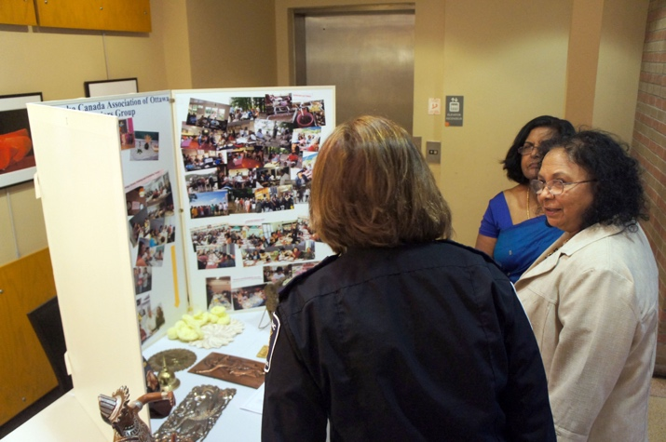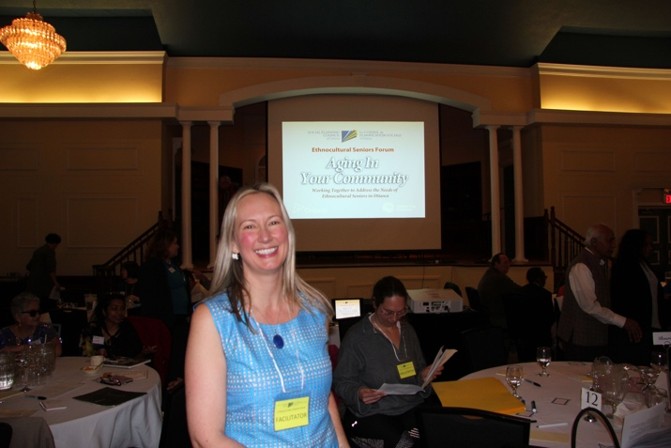
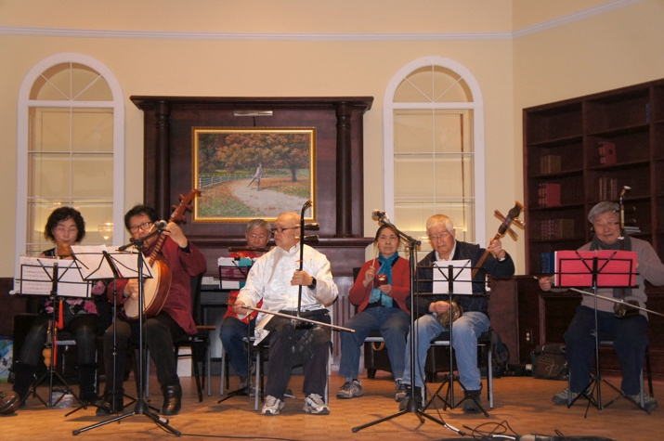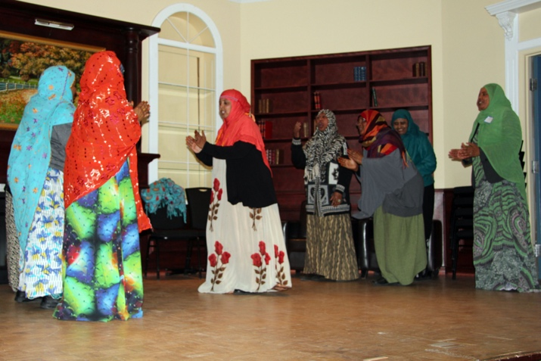
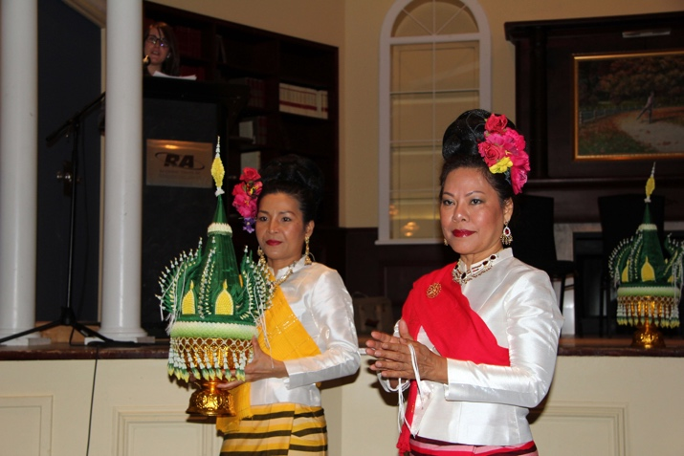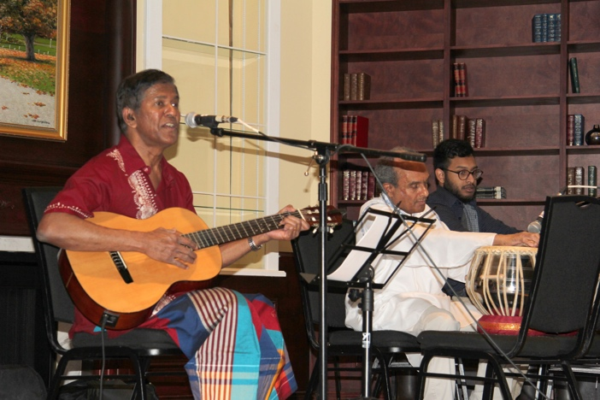
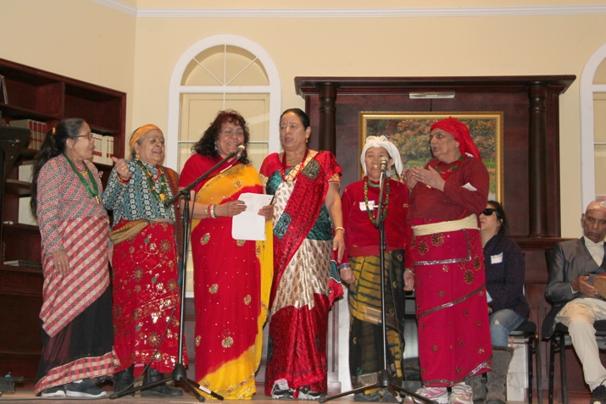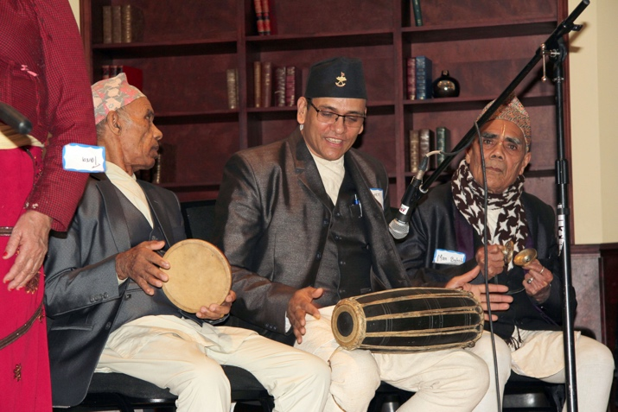

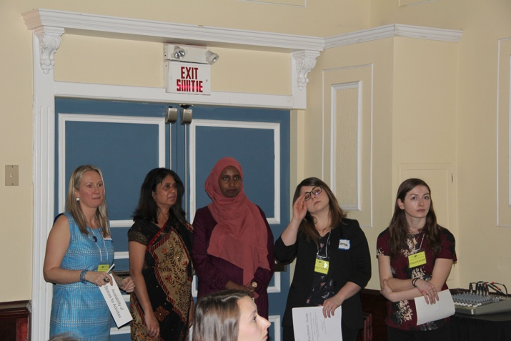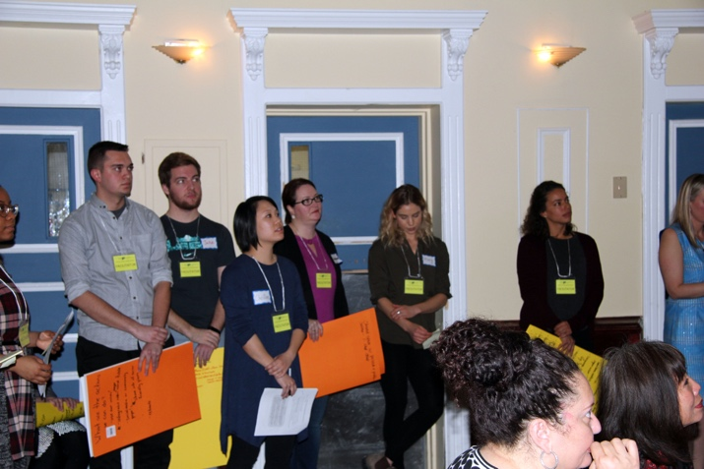
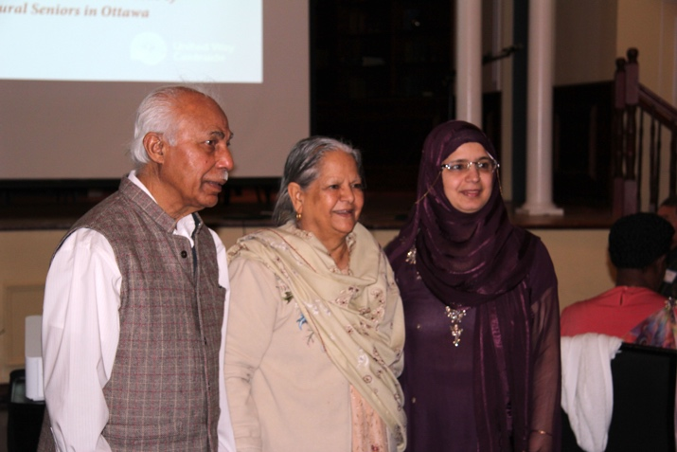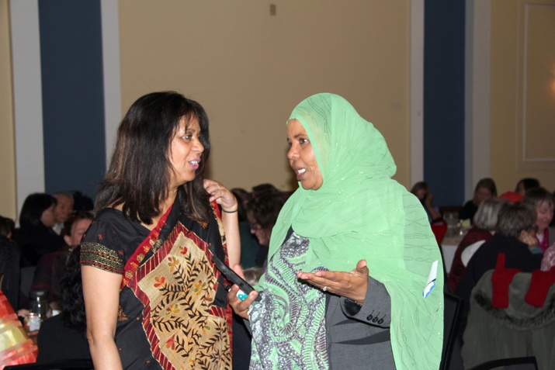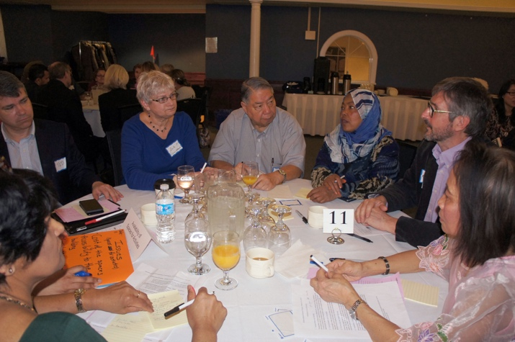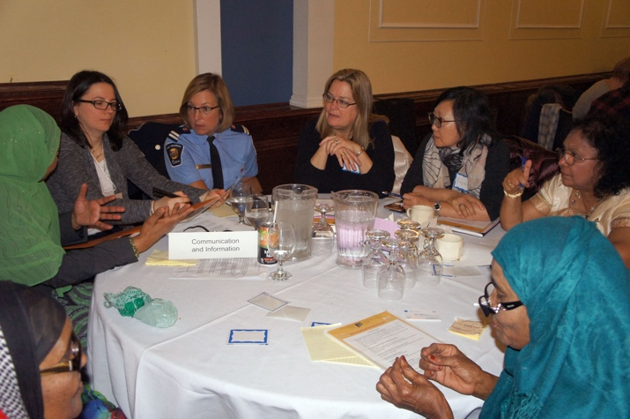
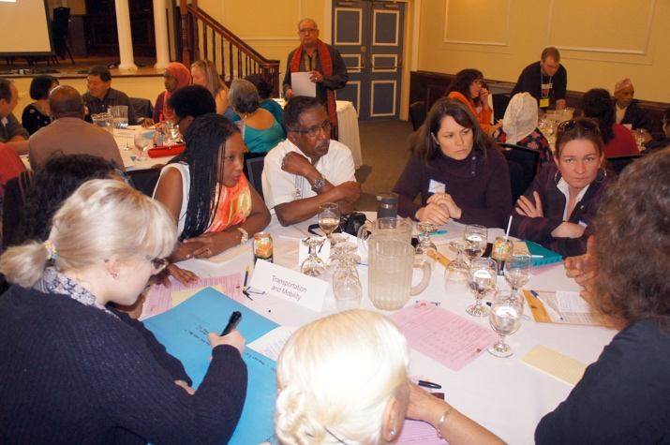

We define ethnocultural as belonging to ethnocultural groups, such as immigrants, national minorities and racial groups.
Seniors refer to 55 years old and over.

